**SYSTEM DESIGN FOR O&O Software Suite**

**1.0 USER MANUAL DESCRIPTION**

O&O Software Suite is a desktop application that is developed using Java Programming Language, MySQL as its database query language. It is hosted on a secured public Server. This manual covers everything required for the successful execution of this application from the database installation to all the modules available in this application and its usage.

* 1. **DATABASE INSTALLATION**

Step 1: Download and Install Xammp server on your system. You can do that by simply typing download Xammp Server on your Firefox or on any browser of your choice.

Step 2: On successful download, Xammp control panel would appear on your search window area right click on it and select run as administrator to open.

Step 3: It appears bottom right on your computer system. You will different modules available like the Apache, MySQL, FileZilla, Mecury and TomCatt. Please note for the purpose of this application we would be using only MySQL and Apache. Navigate to the bad red icon on the Apache and MySQL and click on it to turn it to green.

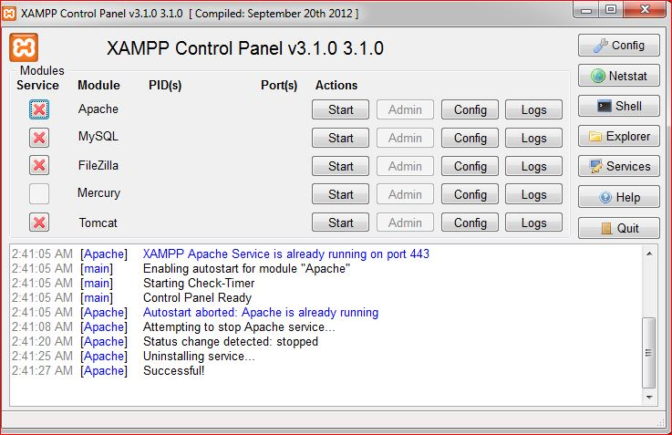

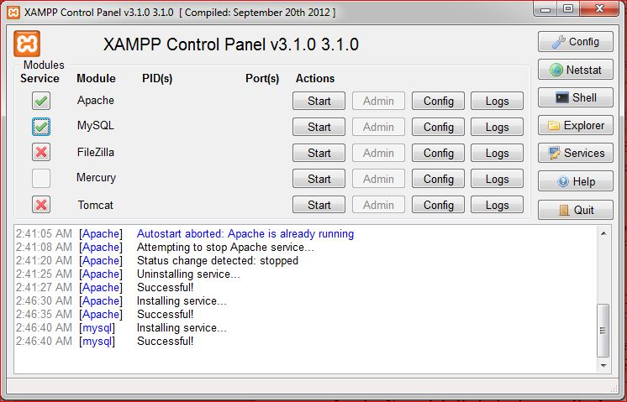

Step 4: When that is done you navigate to the start button for each of them (Apache and MySQL and click on it to start). Please note that It is Advisable to start Apache before MySQL server.

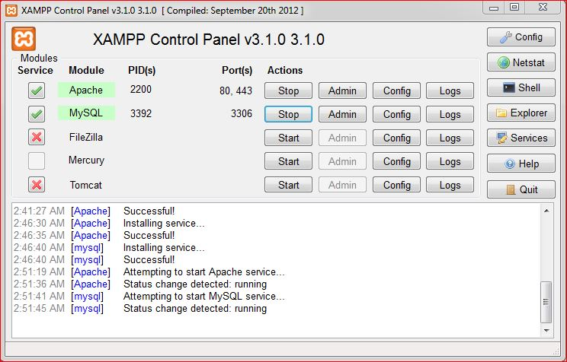

Step 5: When it starts running open up any of your browser and simply type localhost or alternatively 127.0.0.1 on your browser to open up. It loads a page that prompts you select your language. This links you to a new page that is shown below. Navigate down to where you have phpMyAdmin and click to open the admin area

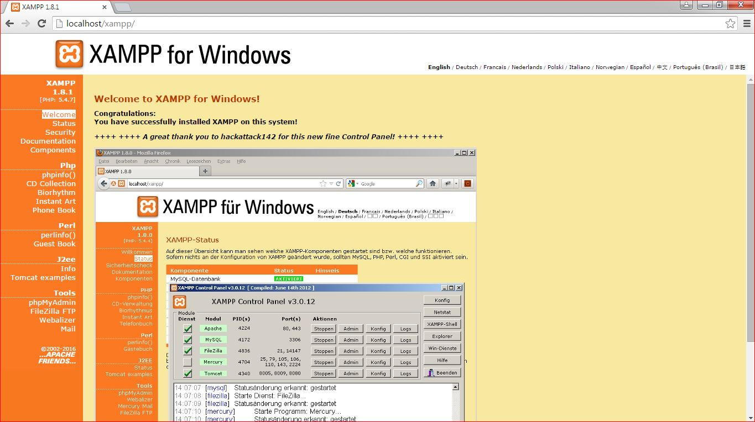

Step 6: The new page opened is where you will create your database name and export your sql file into it. All you need to do is to simply click on Database as shown on the top area of your admin area below. 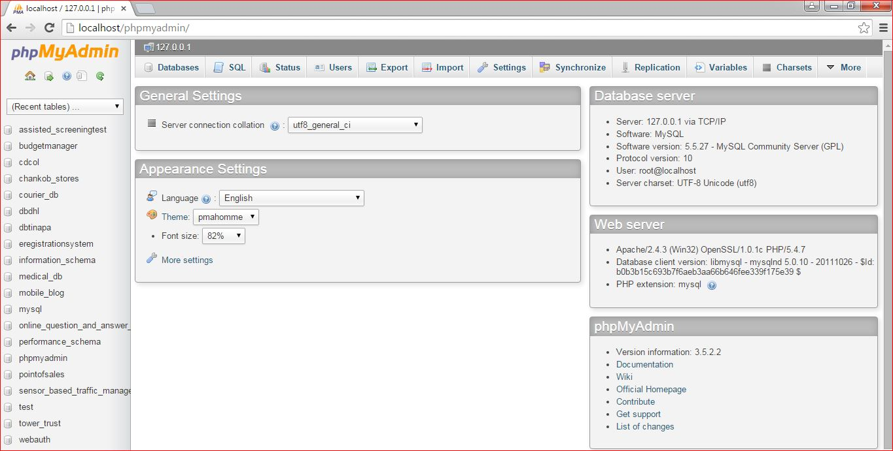

Step 7: Once that is done it opens up a new page for entering your database name. Please make sure you enter the same name as the name you used to create the database of your application which is o\_odb and click on create to create a new database holder.

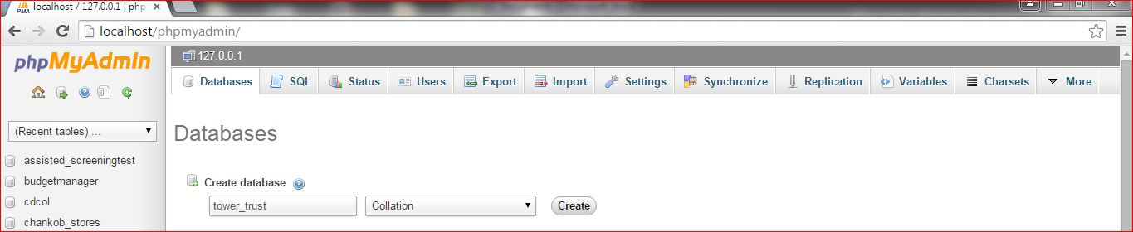

Step 8: Once it is created successfully click on the database which would appear with a list of databases already existing in the server just in the center of the page.

Step 9: At this stage it opens up a new page that has an area for creating of tables. Please note we do not need to create a new table all we simply do is to import our already existing table. All you simply do is to click on the import area and import

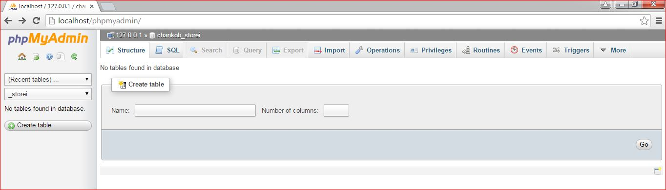

Step 10: The new page that opens now allows you to select your sql file by clicking on browse to select the file. Once the file is located you simple select it and click go which show you a success message if it’s done successfully.

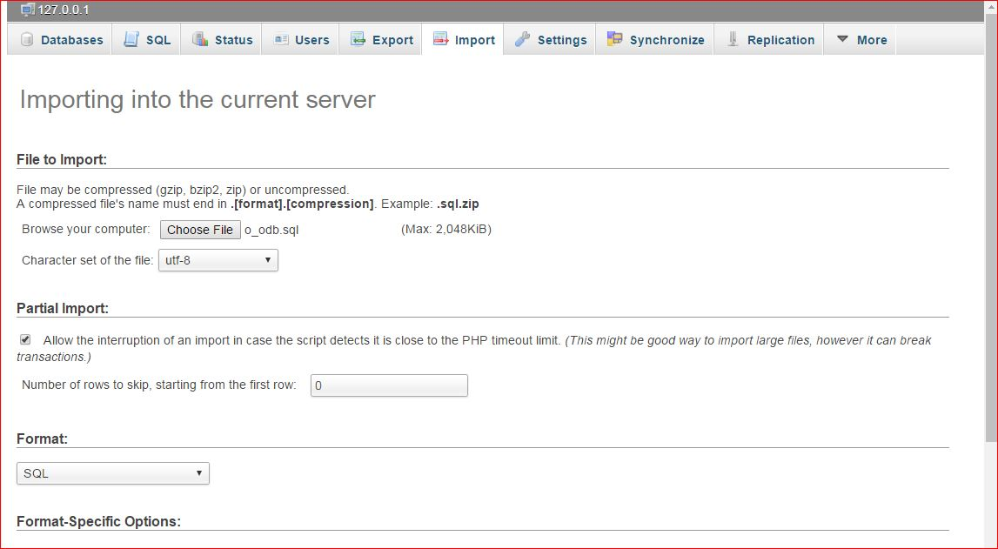

**1.2 RUNNING YOUR APPLICATION**

Now we are done with our database installation we can now proceed to run our application. Please note that our application could be found in our project folder named O\_OSoftwareSuite. Open up and navigate to dist folder to open in fig1 and then click on the executable jar file with name O\_OSoftwareSuite to run as shown in fig2. You can create a shortcut of that on your desktop for easy access

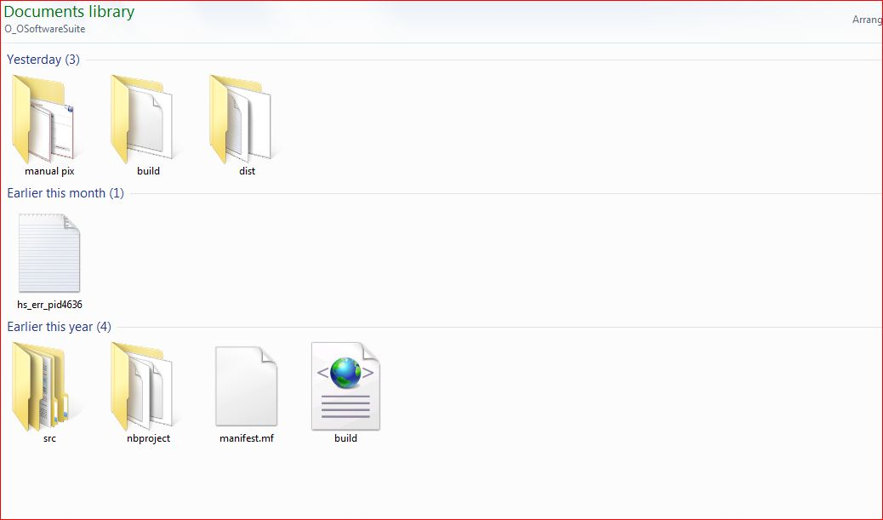Fig 1 Dist Folder

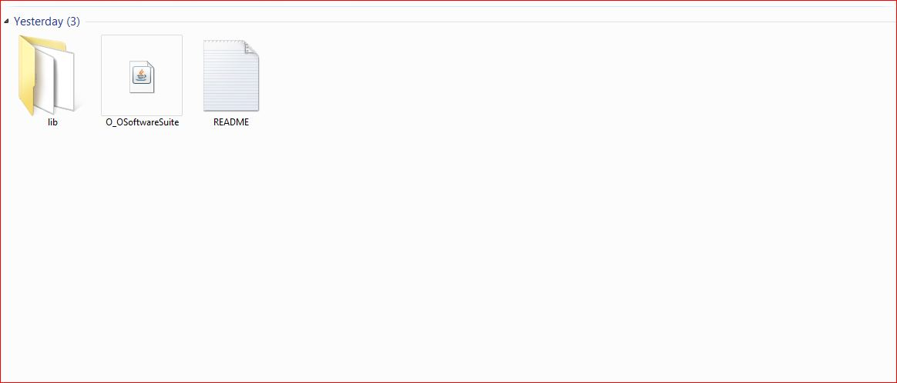

Fig 2: Run Folder

**2.0 USER MODULES**

O&O Software Suite has two major interfaces with each interface containing its own module. The modules represent the different use cases (i.e. different usage of the application) available in the application. The two interfaces are Staff and Manager Interface.

**2.1 STAFF INTERFACE**

This is the interface that is accessible by the staffs/admin of the company. This interface enables the regular staff to set up new customer/distributor, record sales/supply products to customers/distributors, raise invoice for products sold and update customer ledger book. This interface has the following modules which include Customer Setup Module, Sales Record Module, Invoice Raising Module and Ledger Book Update Module.

**2.1.0 Customer Setup Module**

This is the module that is used for setting up a new customer/distributor in the company. This helps to keep electronic record of new customer/distributor data such as customer name, phone, customer type and location and also automatically generates customer id unique to each distributor.

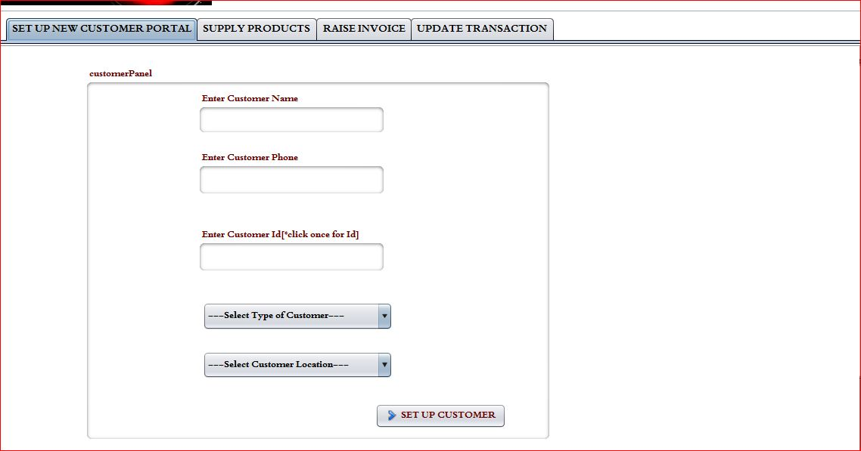

2.1.1 Sales Record Module

This is where sales or products supplied to the different channels of distribution are recorded by the admin. It hold electronic record of every single product sold, the quantity sold, the unit price, amount, ledger Balance, Receipt No and Invoice No.

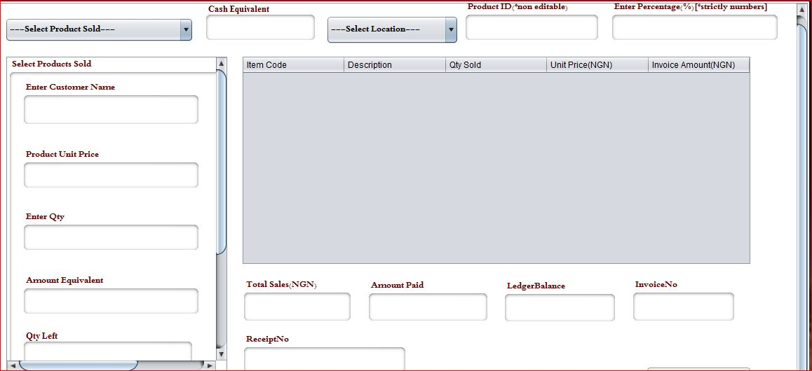

2.1.2 Invoice Raising Module

This is the module that automatically raises an invoice that holds all the values of item that was supplied to a particular distributor, its amount equivalent, the amount received and the balance left. This module can also be printed to be issued to the distributor involved.

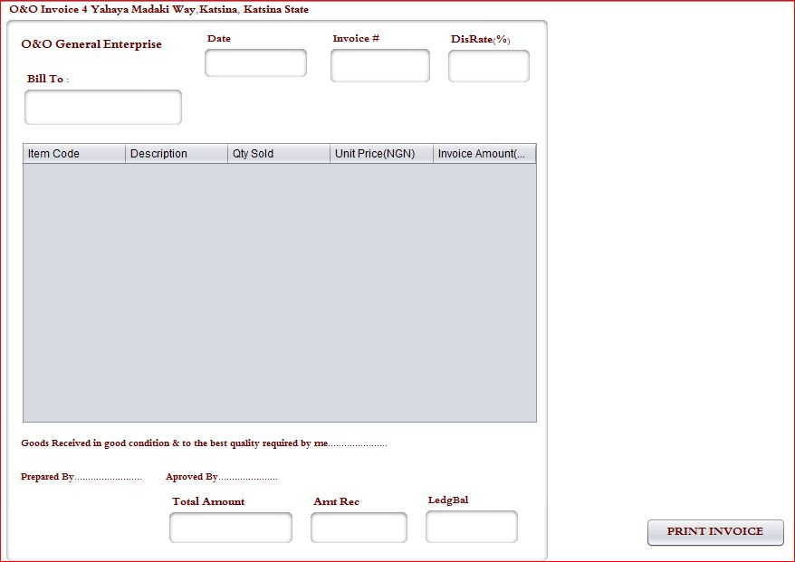

2.1.3 Ledger Book Update Module

This is the module that is used for keeping track of payment as received from the customer or distributor. This module subtracts amount received from customer ledger balance individually.

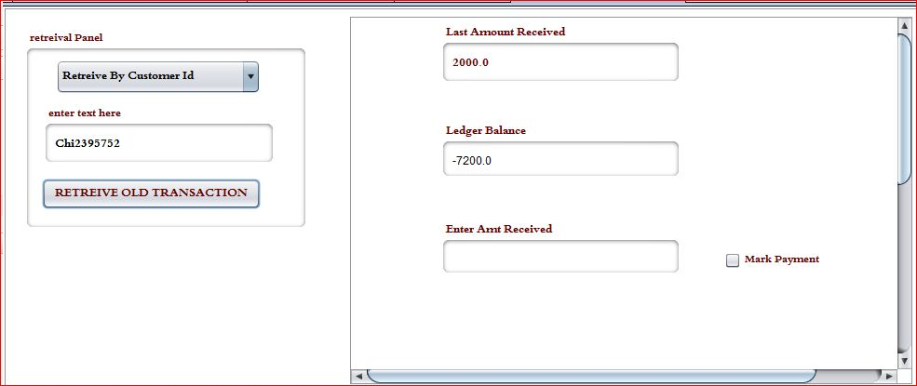

**2.2 MANAGER INTERFACE**

This is the interface that is going to be only accessed by the manager of the company. The manager would be able to stock up goods, distribute goods to branches, check inventory of all goods, view distributed goods, control access to the system, track customer/distributor sales details and print it out for managerial decision making.

2.2.1 Stock up Module

This is the module that stocks up data warehouse by picking the product to stock up, unit price and quantity to stock up. It uses this data to generate the product id for the item.

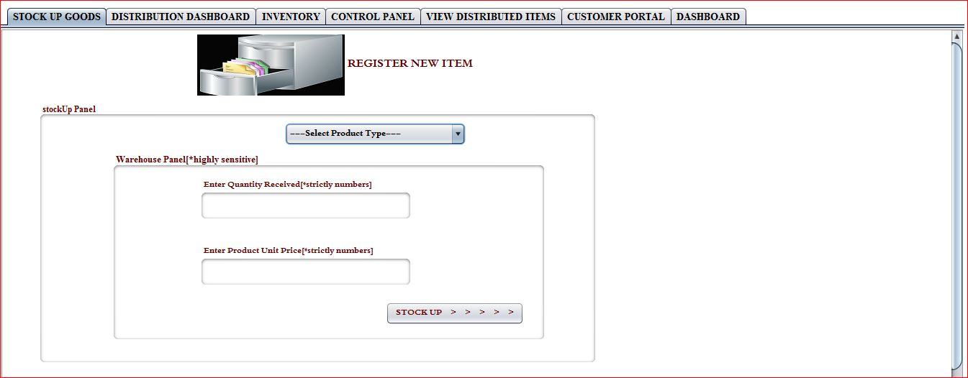

2.2.2 Distribution Module

This is the module that enables the manager to distribute all stocked up items to the branches available in the company. The manger simply selects the product and it automatically retrieves the quantity left in data warehouse for such item, unit price and cash equivalent.

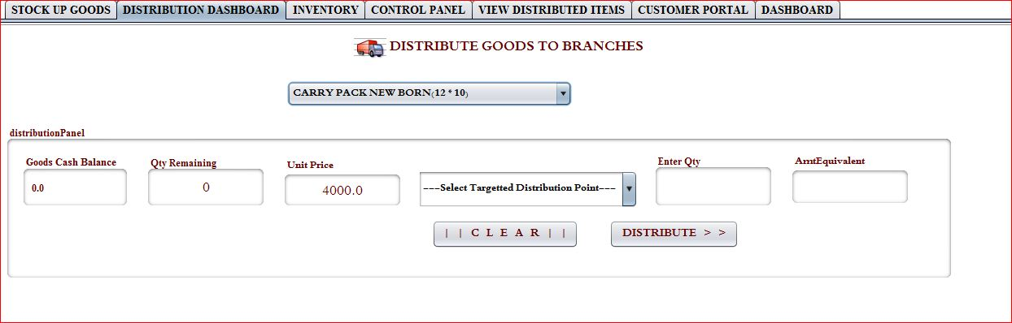

2.2.3 Inventory Module

This is the module that enables the manager to keep inventory of item available in the company warehouse and also at various branches at real time.

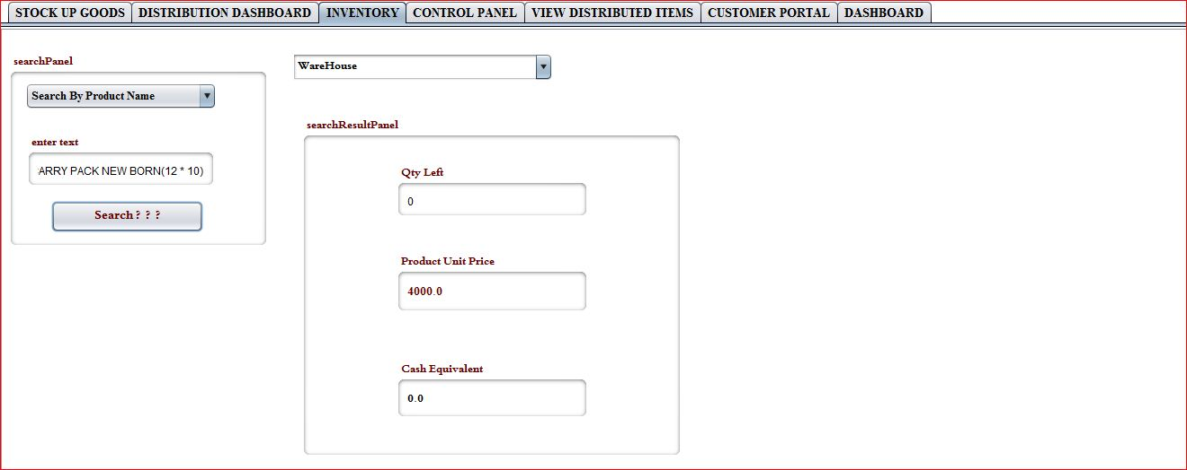

2.2.4 Control Panel Module

This is the module that enables the creation, deletion and viewing of users of this application. The manager is the only authorized person that can grant access to the user of the system.

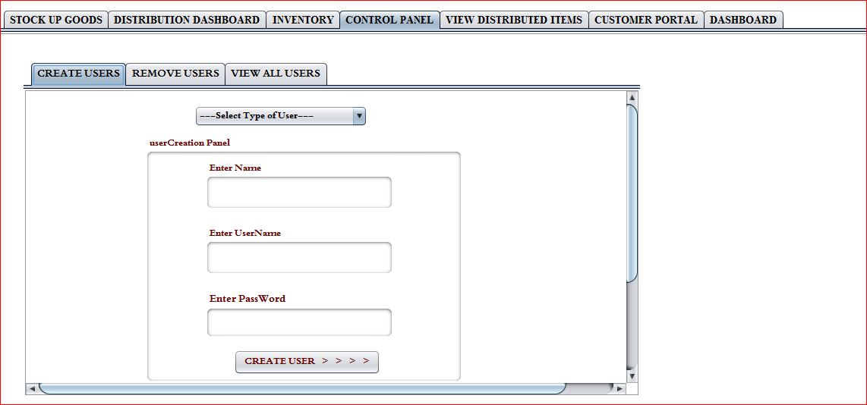

2.2.5 Viewing Distributed Item Module

This is the module that enables the manager to view all the items he distributed to the various branches on daily basis.

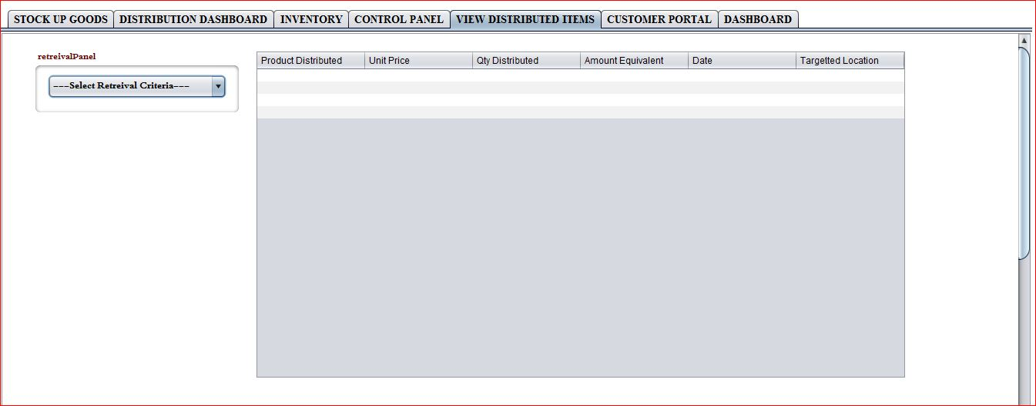

2.2.6 Customer Portal

This is the module that enables the manger keep track of all the different distributors’ activities in the company.

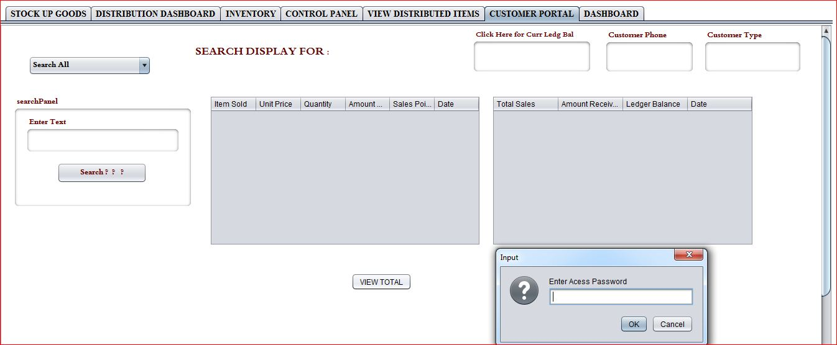

----------Contact Information---------

|  |  |  |  |
| --- | --- | --- | --- |
|  |  |  |  |
| C:\Users\SAMUEL\Documents\NetBeansProjects\mycourier_project\src\images\photo0397_001_001.jpg | **Samuel Iwuchukwu**  Software Engineer  **Tel** : 07065951971, 07059428018  **Email :**samueloel3486@gmail.com , Samytex4life@yahoo.com |  |  |